Jules Zimmerman

614-581-2276

[Zimmer13@miamioh.edu](mailto:Zimmer13@miamioh.edu)

I am currently working on a personal portfolio project where I code and design my own website featuring my work.

Below are my two most proud previous works that I have completed via Adobe Illustrator.

I am skilled in Adobe Illustrator, Photoshop, Premiere Pro, and InDesign.

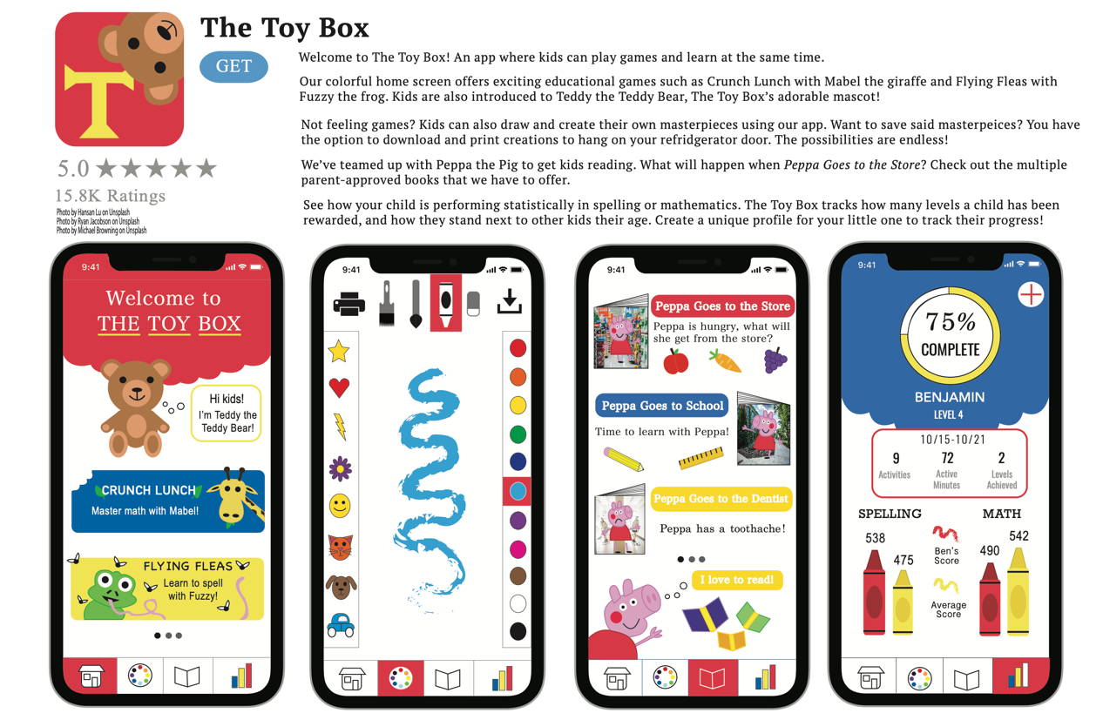

In one of my design classes we were asked to create an app from scratch, and due to my love for color and children, I created The Toy Box. It is an educational and playful app that tracks children’s reading and math levels, while also allowing them to play fun games or paint pictures.



In my graphic design class, we were asked to solve an issue in a rather unique way. My issue involved babies crying on planes. This in turn developed into The Mom Box. This is originally where The Toy Box was curated.

Below are a couple examples of HTML pages that I have coded. My languages include HTML, CSS, JavaScript, and jQuery.

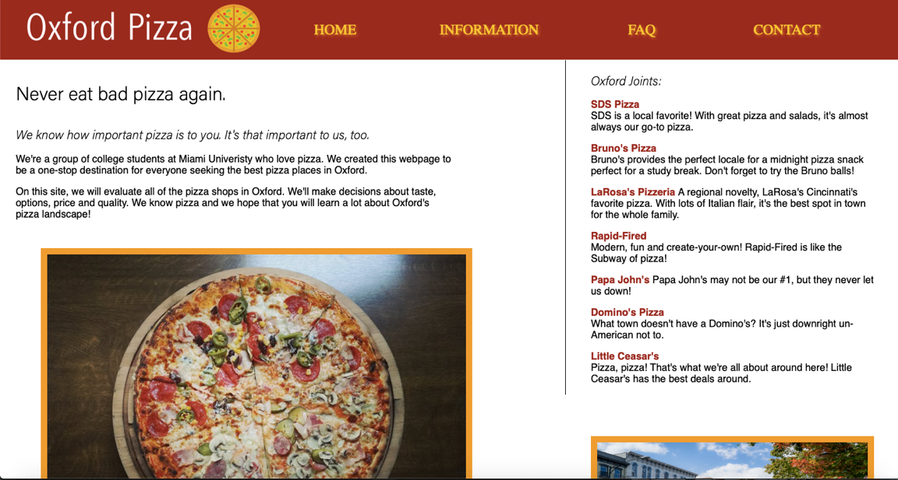

We were asked to create a website for our favorite food around Oxford. Who doesn’t like pizza!

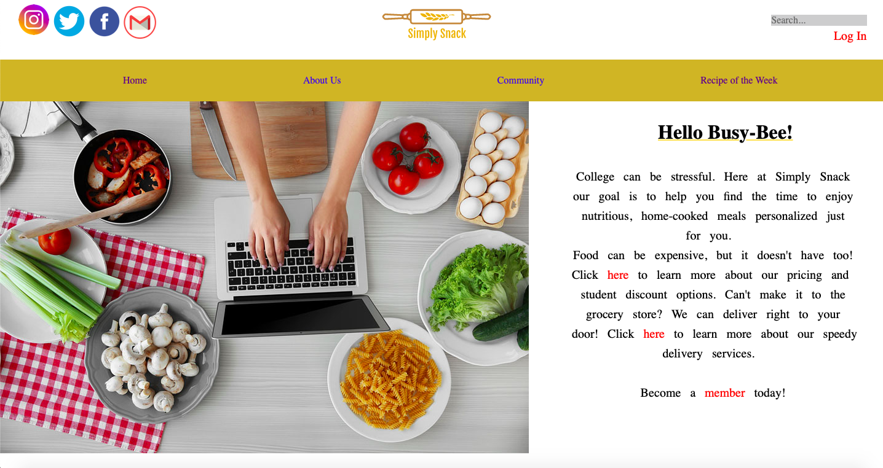

When challenged to create a website for college students to improve their diet, I came up with a delivery service called Simply Snack. This app would deliver prepped meals to college students doors so they don’t waste time, energy, and can eat something healthy.